CPS470: Computer Networks and Security

Written Homework 3
Total Points: 100

Note: In all written assignments, please show as much of your work as you can. Even if you get a wrong answer, you can get partial credit if you show your work. If you make a mistake, it will also help the grader show you where you made a mistake. You can either type your answers in the solution area and submit the file directly on Isidore or hand-write your answers and get a scanned version of it to submit on Isidore. If you find the default space is not sufficient for you to type/handwrite your answers, please feel free to enlarge the space as needed. Please make sure your handwriting is clear and understandable. If the grader or I cannot understand your handwriting, you get zero for your solutions.

Problem 1: UDP and TCP checksum [15 points]. Suppose you have the following two bytes 00110101 and 01101001.

- What is the ones complement of these two bytes?
- What is the ones complement sum of these two bytes?
- For the bytes in part (a), give an example where one bit is flipped in each of the two bytes and yet the one’s complement sum doesn’t change.

Solution:

a)
00110101 complement is 11001010
01101001 complement is 10010110

b)
00110101
+ 01101001
10011110 complement is 01100001

c)
We change 00110101 to 00110100, and 01101001 to 01101010 and the outcome is still the exact same as before.

00110100
+ 01101010
10011110 complement is 01100001

Problem 2: [24 points] Consider the rdt2.2 protocol, its FSMs for the sender and receiver are shown below:
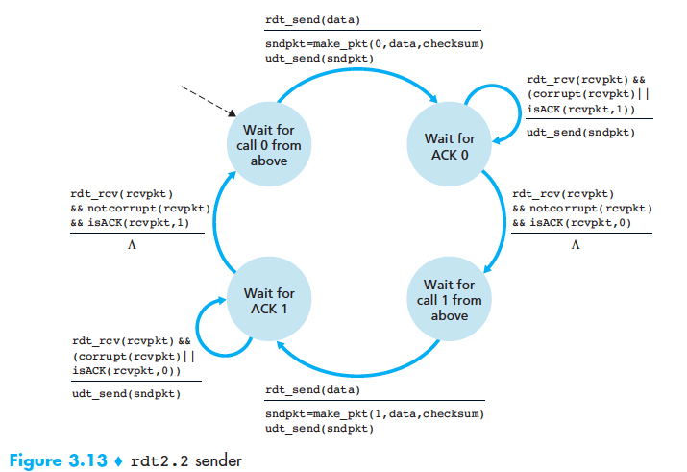
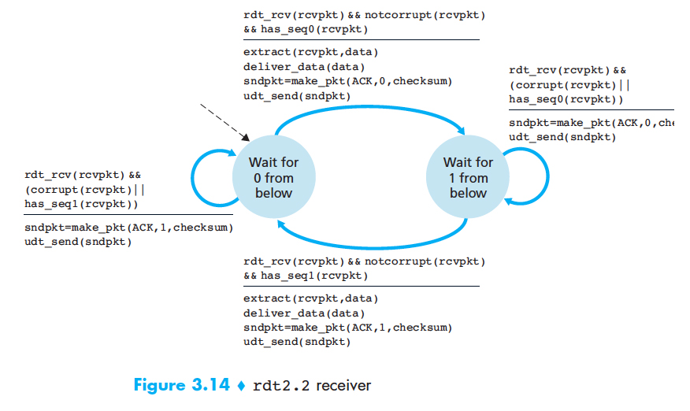
Suppose that the channel connecting the sender and receiver can corrupt but not lose or reorder packets. Now consider the figure below, which shows four data packets and three corresponding ACKs being exchanged between a rdt 2.2 sender and receiver. The actual corruption or successful transmission/reception of a packet is indicated by the corrupt and OK labels, respectively, shown above the packets in the figure below.
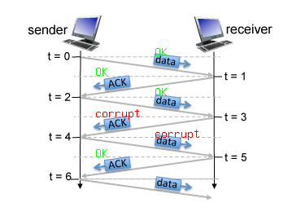
Note: When answering the following questions, refer to the states defined in the rdt 2.2 protocol.

Between time t=0 and t=1, what is the sender state?
Your answer: wait for Ack 0
Between t=0 and t=1, what is the receiver state?
Your answer: Wait for 0 from below
Between t=0 and t=1, what is the sequence/ack # of the packet?
Your answer: 0
Between t=1 and t=2, what is the sender state?
Your answer: wait for Ack 0
Between t=1 and t=2, what is the receiver state?
Your answer: wait for 1 from below
Between t=1 and t=2, what is the sequence/ack # of the packet?
Your answer: 0
Between t=3 and t=4, what is the sender state?
Your answer: wait for Ack 1
Between t=3 and t=4, what is the receiver state?
Your answer: wait for 0 from below
Between t=3 and t=4, what is the sequence/ack # of the packet?
Your answer: 1
Between t=4 and t=5, what is the sender state?
Your answer: Wait for Ack 1
Between t=4 and t=5, what is the receiver state?
Your answer: wait for 0 from below
Between t=4 and t=5, what is the sequence/ack # of the packet?
Your answer: 1

Problem 3: Two senders, an alternating receiver. [20 points]. Consider the figure below in which a TCP sender and receiver communicate over a connection in which the sender to receiver segments may be lost. The TCP sender sends an initial window of 5 segments. Suppose the initial value of the sender to receiver sequence number is 100 and the first 5 segments each contain 250 bytes. The delay between the sender and receiver is 7 time units, and so the first segment arrives at the receiver at t=8. As shown in the figure below, 3 of the 5 segment(s) are lost between the segment and receiver, which are indicated by the red cross symbol.
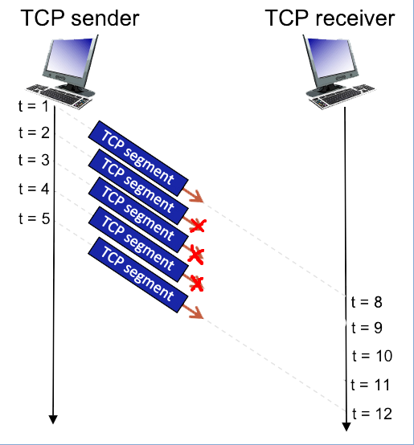
[10 points] Please give the sequence numbers associated with each of the 5 segments sent by the sender.
Your answer:
Segment 1: Starts at the ISN – Sequence Number: 100 (Contains bytes 100 to 349)
Segment 2: 100 + 250 – Sequence Number: 350 (Contains bytes 350 to 599)
Segment 3: 350 + 250 – Sequence Number: 600 (Contains bytes 600 to 849)
Segment 4: 600 + 250 – Sequence Number: 850 (Contains bytes 850 to 1099)
Segment 5: 850 + 250 – Sequence Number: 1100 (Contains bytes 1100 to 1349)

[10 points] Please provide the sequence numbers of the ACK segments that the receiver sends in response to each received segment. If a segment never arrives use 'x' to denote it.
Your answer:
Segment 1: 350 – segment arrived successfully and contains 100-349, so now the receiver expects 350.
Segment 2: x
Segment 3: x
Segment 4: x
Segment 5: because segments 2 through 4 are missing, it will not send back the 1350 like you would expect, instead it will resend 350 since it sends a duplicate of the last segment if there is an error/gap.

Problem 4: Pipelined Protocol Part I [15 points] In this question we’ll explore the pipelined protocols (Go-Back-N and Selective Repeat). The following figures show the sender and receiver window of those two pipeline protocols, respectively.

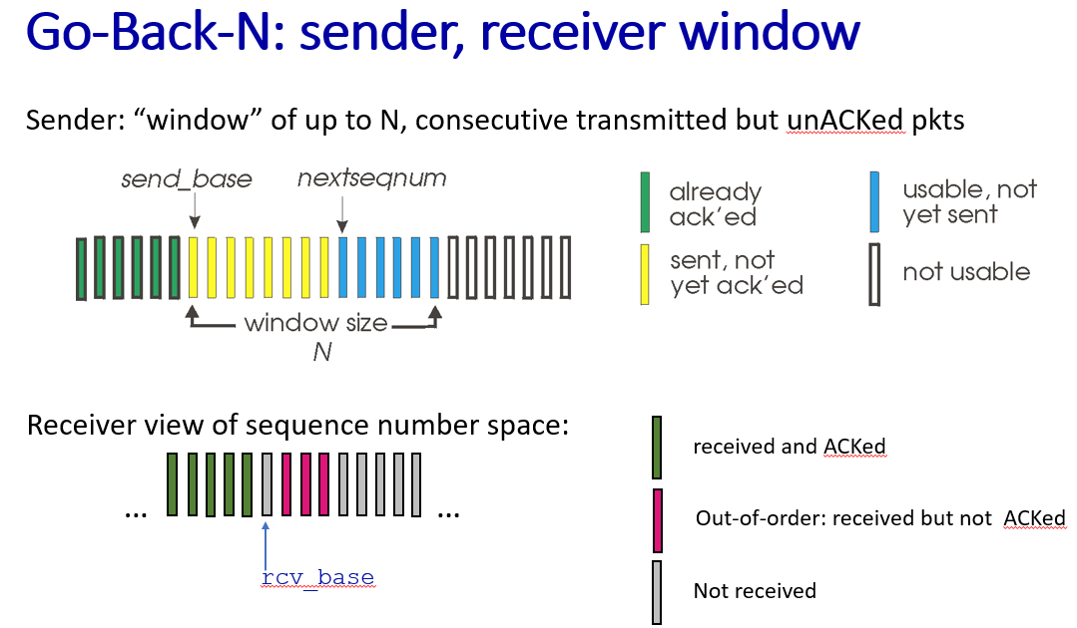

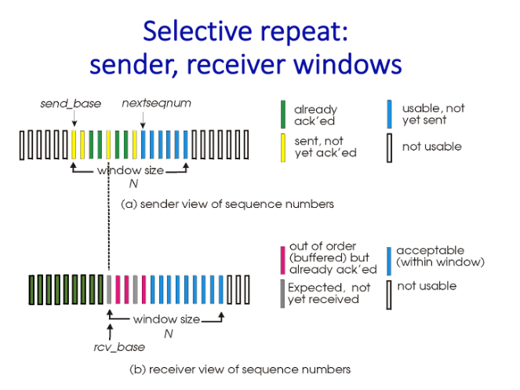

- 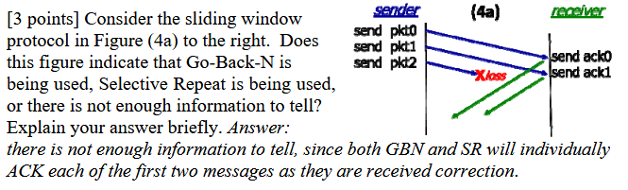

There isn’t enough information to tell, both Go-back-N and selective repeat will ACK the first 2 messages since they ran correctly

- 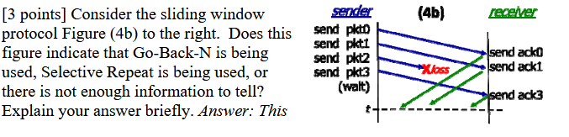

The answer is Selective repeat. If it was Go-back-n, we would see that when it received pkt3, it would send back ack1 because it received the packets out of order.

- [9 points] Refer again to Figure 4(b). Assume several acknowledgments (ACKs) are currently propagating from the receiver to the sender at time t. For each of the following possible events that may occur at the sender in the future, only describe the sender’s action. Note: These events do not occur sequentially; analyze each one independently.

  - The next event is ACK0 received — what will the sender do?
  - The next event is ACK1 received (assuming ACK0 was lost) — what will the sender do?
  - If ACK0, ACK1, and ACK3 are all lost, the next event will be a timeout. Since no ACKs have been received, what action will the sender take?

Answer:
- The sender will mark pkt0 as acknowledged and will slide to the next packet which is pkt1
- Since we are using selective repeat, we will not slide forward, instead we will stay at pkt0 and wait for ACK0
- It will resend pkt0, pk1, pk2, and pkt3 when their respective timeouts happen. So pkt0 will timeout first and therefore we will resend pkt0, and then we will send pk1 after when its timeout occurs, pkt2 never made it to the receiver so it never generated an ACK2 to fail, so it will timeout like the rest and we will resend it third. Lastly, when pk3 times out we re-send it.

Problem 5: Pipelined Protocol Part II [26 points]
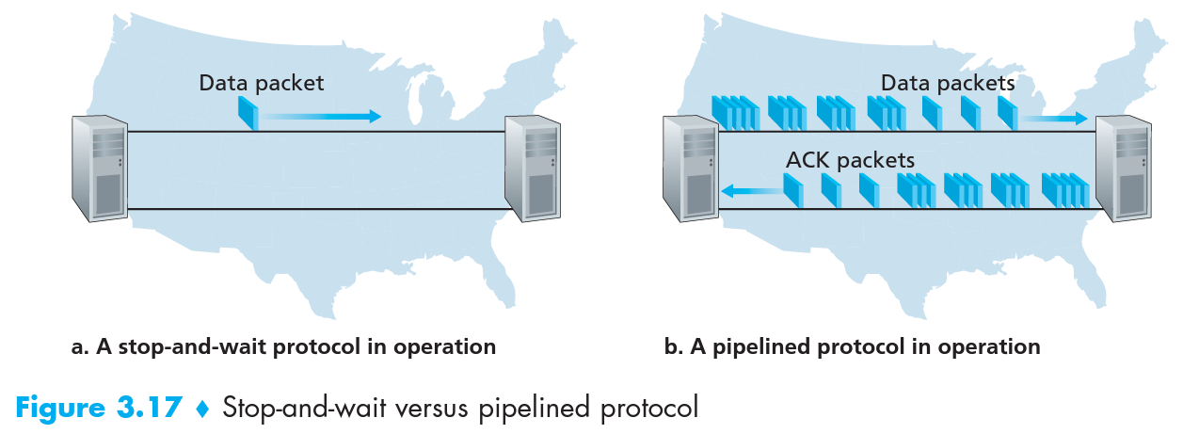

Consider an idealized case of two hosts, one located on the West Coast of the United States and the other located on the East Coast, as shown in Figure 3.17. The speed-of-light round-trip propagation delay between these two end systems, RTT, is approximately 30 milliseconds. Suppose that they are connected by a channel with a transmission rate, R, of 1 Gbps (10⁹ bits per second). With a packet size, L, of 1,000 bytes (8,000 bits) per packet, including both header fields and data, the time needed to actually transmit the packet into the 1 Gbps link is
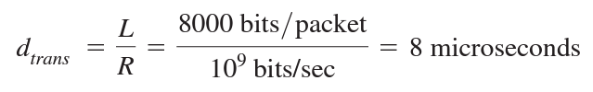

- Consider the cross-country example in Figure 3.17. How big would the window size have to be for the channel utilization to be greater than 80 percent? You may assume that the size of a packet is 1500 bytes, including both header and data.
- For the Go-Back-N protocol, give an example (i.e., a timeline showing the sender and receiver and the messages they exchange, e.g., as page 67 or 71 in the transport layer slides) showing a Go-Back-N sender receiving an ACK for a packet that currently falls outside its window. (Note: you can determine the sequence number and sliding window size by yourself)
- For the Selective Repeat Protocol, give an example (i.e., a timeline showing the sender and receiver and the messages they exchange, e.g., as page 67 or 71 in the transport layer slides) showing a SR receiver receiving an ACK that is within its window, but for which it cannot advance its sending window forward. (Note: you can determine the sequence number and sliding window size by yourself)

Solution:
- Utilization = (window size) * (transmission time) / (RTT + (Transmission Tme) )
Transmission time = L/R = 8 microseconds = 8*10⁻⁶ seconds
RTT = 30 milliseconds = 0.03 seconds
Utilization (0.80) = W * (8*10⁻⁶) / (0.03 + (8*10⁻⁶))
0.80 * (0.03 + (8*10⁻⁶)) = W * (8*10⁻⁶)
W = 0.80 * (0.03 + (8*10⁻⁶)) / (8*10⁻⁶)
Window Size = 3000.8
- Using window size of 3 and sequence of 5
Sender: Sends Packets 0, 1, 2
Receiver: receives packets 0, 1, 2; sends ack0, ack1, and ack2
Sender: receives ack0, ack1 and ack2; moves window to 3, 4, 0; sends packets 3, 4
Receiver: receives packets 3, 4; sends ack3, ack4; ack3 is lost
Sender: receives a late ack0 which is out of current window and already acknowledged, so it is ignored
- Using window size of 2 and sequence of 3
Sender: Sends Packets 0, 1; 0 is lost
Receiver: receives packet 1; sends ack1
Sender: receives ack1; sends packet 2
Receiver: receives packet 2; sends ack2; wont advance window since it is missing packet 0

